# Author: Brandon Cocanig  
# Assignment: Gpa A2  
# Due: September 12, 2019  
print('\nWelcome to the GPA calculator.')  
print('Please enter all your letter grades, one per line. {A+-F}')  
print('Enter a blank line to designate the end.')  
  
# map from letter grade to point value  
points = {'A+': 4.0, 'A': 4.0, 'A-': 3.67, 'B+': 3.33, 'B':3.00, 'B-': 2.67, 'C+': 2.33, 'C': 2.00, 'C-': 1.67, 'D+': 1.33, 'D': 1.0, 'F': 0}  
  
num_courses = 0  
total_points = 0  
  
done = False  
while not done:  
 grade = input()  
 if grade == '':  
 done = True  
 elif grade not in points:  
 print("Unknown grade '{0}' being ignored".format(grade))  
 else:  
 num_courses += 1  
 total_points += points[grade]  
if num_courses > 0:  
 print('Your GPA is {0:.3}'.format(total_points / num_courses))

Results------------------------------

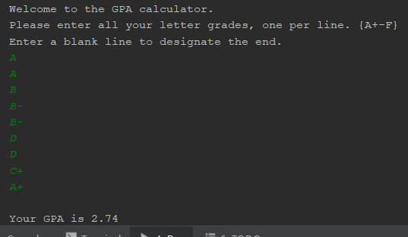

This code works by taking user input in the form of strings and compares if those inputs are in the list “points” if they are inside this list it will then map that input to a value. (i.e. A- =3.67). With this numerical value you can divide the total number of user inputs (i.e. classes taken) you will then get your overall GPA.

Lists

Lists in python are a way to store elements. Each element is then of is assigned a number in sequence. The first element entered will be indexed at zero, the second index will be one, etc etc. Lists allow for many different operations include indexing, slicing, adding, multiplying, and checking for membership. All of which can make lists extremely useful for storing data that will be called during execution of the code.